SECTION A: Multiple-choice questions

Question 8
The waste water from a chemical plant was found to contain NaOH at a concentration of 0.10 M. What volume of 0.01 M HCl solution would be required to neutralize 1000L of the waste water?
- 10000L and the concentration of the hydroxide ions would decrease and the pH would increase.
- 10000L and the concentration of the hydroxide ions would decrease and the pH would decrease.
- 1000L and the concentration of the hydrogen ions would decrease and the pH would increase.
- 1000L and the concentration of the hydrogen ions would increase and the pH would increase.

Questions 9, 10 and 11 refer to the following information.

The caffeine content of two brands of coffee was tested using high pressure liquid chromatography (HPLC). One brand being tested was an instant coffee, while the other was decaffeinated. The following results were obtained.

Retention Time (min)

Caffeine Standard
Current

Decaffeinated Coffee
Retention Time (min)
Current

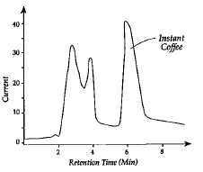
Instant Coffee
Retention Time (min)
Current

Question 9
The retention time measured for caffeine in the tests above is a measure of:
- The time taken to inject the sample of coffee into the instrument.
- The time required for the solvent to move through the instrument.
- The time it takes caffeine to pass through the column in the instrument.
- The amount of caffeine in the sample.

Question 10
The results obtained indicate that:
- The retention time for caffeine is two minutes.
- The brand of decaffeinated coffee still contains large quantities of caffeine.
- The amount of caffeine in the instant coffee is negligible.
- The amount of caffeine in the decaffeinated coffee is negligible.

Question 11
Another brand of coffee was found to contain 4.0% by mass of caffeine. If 2.0 g of this product is used to make a 150 mL cup of coffee, then the concentration of caffeine in the coffee cup would be:
[M (caffeine) = 194 g mol⁻¹]
- 0.0027 M
- 0.27 M
- 0.010 M
- 0.069 M

SECTION B

Question 1 (5 marks)
Sodium thiosulfate (Na₂S₂O₃), has been used to treat people with kidney disease.
It is useful in analytical chemistry because the thiosulfate ion, S₂O₃²⁻ reacts with iodine, I₂ in aqueous solution, reducing it to iodide, I⁻ as it is oxidized to persulfate ion, S₂O₈²⁻.

        - Write the half equation that represents the reduction process in this reaction.

___________________________________________________________________________
(1 mark)

        - Write the half equation that represents the oxidation process in this reaction.

___________________________________________________________________________
(1 mark)

        - Determine the overall reaction between the thiosulfate ion and iodine. Include states.

___________________________________________________________________________
(2 marks)

        - Identify the oxidation number of sulfur in the thiosulfate ion.

___________________________________________________________________________

(1 mark)
Question 3 (14 marks)

Tartaric acid (H₂C₄H₄O₆) makes up a major proportion of the total acid content of wine.

A 750 mL bottle of wine was tested for its tartaric acid content. A 20.00 ml aliquot of the wine was reacted with 10.00 mL of a 0.360 M sodium hydroxide solution. The following reaction occurred:

H₂C₄H₄O₆(aq) + 2NaOH(aq) → Na₂C₄H₄O₆(aq) + 2H₂O(l)

The excess sodium hydroxide solution required a 17.40 mL titre of 0.115 M hydrochloric acid standard to neutralize it according to the equation:

NaOH(aq) + HCl(aq) → NaCl(aq) + H₂O(l)

- Write an ionic equation for the neutralization of the excess sodium hydroxide with hydrochloric acid.

_______________________________________________________________________________________
(1 mark)

- Calculate the amount, in mole, of the hydrochloric acid which was used in the titration.

______________________________________________________________________________________________________________________________________________________________________________
(1 mark)

- Determine the amount, in mole, of the sodium hydroxide which reacted with the hydrochloric acid.

_______________________________________________________________________________________
(1 mark)

- Calculate the number of mole of sodium hydroxide which reacted with the tartaric acid in the wine.

_______________________________________________________________________________________
_______________________________________________________________________________________
_______________________________________________________________________________________
_______________________________________________________________________________________
(2 marks)

- Calculate the mass of tartaric acid in the 20.00 mL aliquot.
_______________________________________________________________________________________
____________________________________________________________________________________________________________________________________________________________________________________________________________________________________________________________________________________________________________________________________________________________
(2 marks)

- Calculate the mass of tartaric acid in the 750 mL bottle of wine.

____________________________________________________________________________________________________________________________________________________________________________________________________________________________________________________________________________________________________________________________________________________________
(1 mark)
- Draw a pH curve for the titration between the sodium hydroxide, NaOH and hydrochloric acid, HCl. Include all relevant information in your graph.
Volume (mL)

pH

( 2 marks)
- Choose a suitable indicator for the reaction between the excess sodium hydroxide and the hydrochloric acid and provide a reason for your choice.

____________________________________________________________________________________________________________________________________________________________________________________________________________________________________________________________________________________________________________________________________________________________
(2 marks)
- Sodium hydroxide solution should not be left standing as it reacts with carbon dioxide in the air. Explain the effect on the calculated value for the acidity of wine if the solution of sodium hydroxide had been left in an open bottle for a couple of days before adding it to the wine.

___________________________________________________________________________________________________________________________________________________________________________________________________________________________________________________________________________________________________________________________________________________________________________________________________________________________________________________

(2 marks)

SECTION A: Multiple-choice questions
Question 1
There are four different proton environments in 1-propanol. The diagram below labels two of these proton environments.
I II
$${CH}_{3}-{CH}_{2}-{CH}_{2}-OH$$

In the ¹H NMR spectrum of 1-propanol, the proton environments labelled as I and II will appear as:

- I: triplet at 0.8-1.0 ppm II: quartet at 3.3-4.5 ppm
- I: quartet at 0.8-1.0 ppm II: triplet at 3.3-4.5 ppm
- I: triplet at 0.8-1.0 ppm II: triplet at 3.3-4.5 ppm
- I: triplet at 3.3-4.5 ppm II: quartet at 0.8-1.0 ppm

Question 2
An alkanol has the molecular formula C₄H₁₀O. Its ¹³C NMR spectrum consists of four signals. Which of the structures below is consistent with this information?

- CH₃CH₂CH₂CH₂OH
- CH₃CH₂CH(OH)CH₃
- CH₃CH(CH₃)CH₂OH
- CH₃CH₂CH₂OH

Question 3
Which of the following spectroscopic techniques (I – V) result in the excitation of electrons?
I UV-visible spectroscopy | II Atomic Absorption Spectroscopy | III Mass spectrometry
IV NMR spectroscopy | V IR Spectroscopy

- I and II
- III and IV
- I and V
- IV and V

Question 4
Parent molecular ion
X
The mass spectrum of ethanoic acid is shown above. The parent molecular ion (m/z = 60) has the formula CH₃COOH⁺. When this ion breaks up, other fragments are produced.
The peak labelled ‘X’ occurs at m/z = 43. Which of the following fragments could have been lost from the parent molecular ion to produce this peak?

- OH∙
- OH⁺
- CH₃∙
- CH₃⁺

Question 5
A Chemist wants to determine if an unlabeled bottle contains 1-propanol or 2-propanol. Which one of the analytical techniques below would be the best suited to identify the alkanol if there were no standards available?

- UV-visible spectroscopy
- IR spectroscopy
- Atomic absorption spectroscopy
- ¹H NMR spectroscopy

Question 6
Compound 1 | Compound 2
The two compounds shown above are correctly named as:

Compound 1 Compound 2
- 2-methylbutan-2-ol 3-methylbutan-2-amine
- 2-methylbutan-2-ol 2-methylbutan-3-amine
- 1,1-dimethylprop-1-ol 3-methylbutan-2-amine
- 1,1-dimethylprop-1-ol 2-methylbutan-3-amine

Question 7
A compound has the molecular formula C₃H₆X. The atom X is most likely to be:

- hydrogen
- nitrogen
- oxygen
- chlorine

Question 8
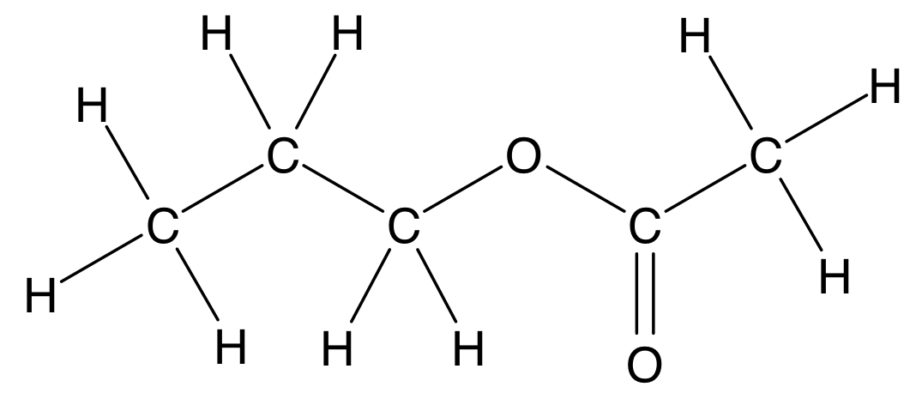
The ester shown above was most likely made from the following compounds:

- propanoic acid and ethanol
- ethanoic acid and 1-propanol
- propanoic acid and 1-propanol
- ethanoic acid and ethanol

SECTION B

Question 1 (18 marks)
Esters are responsible for some of the natural and synthetic flavours and smells in sweets. The table below shows three different esters commonly used in a sweets factory.

- Complete the missing semi-structural formulas and systematic names for the esters listed in the table below.

Ester | Semi-structural formula | Smell or flavour
Pentyl butanoate |  | Pear
 | CH₃CH₂CH₂CH₂COOCH₂CH₃ | Apple
 | CH₃CH₂CH₂CH₂COOCH₂CH₂CH₂CH₃ | Raspberry
(3 marks)

- The production manager suspects that the three different esters listed in the table above (Q1a.) have been labelled incorrectly. A ¹H-NMR analysis of one of the samples is shown below.

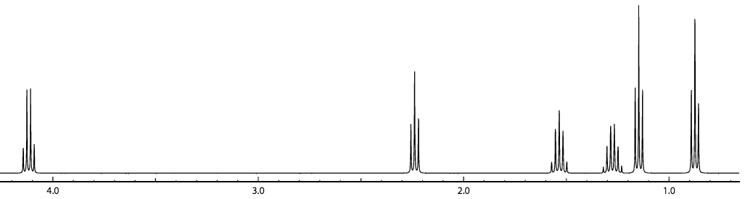
Peak A
Peak B
Chemical Shift (ppm)

- How many different chemical environments can be seen in this ¹H-NMR spectrum?

- Which of the three esters listed above (Q1a.) is the one responsible for this ¹H-NMR spectrum?

- Draw the structural formula of this ester.

- In the structure drawn above (Q1b. iii), circle and label the hydrogens responsible for Peak A and Peak B shown on ¹H-NMR spectrum in (Q1b.). Explain below:

The splitting pattern of Peak A:
Why Peak A appears further downfield than Peak B:

- Apart from ¹H-NMR spectroscopy, what other spectroscopic technique could you use to clearly identify the ester in the sample? Explain your answer.
(1 + 1 + 1 + 4 + 2 = 9 marks)

- The production manager wants to introduce a new banana flavour, given by the ester butyl ethanoate. Complete the organic pathway below to show how butyl ethanoate could be synthesised.
butane
Compound A
Structural formula:

Conditions II:

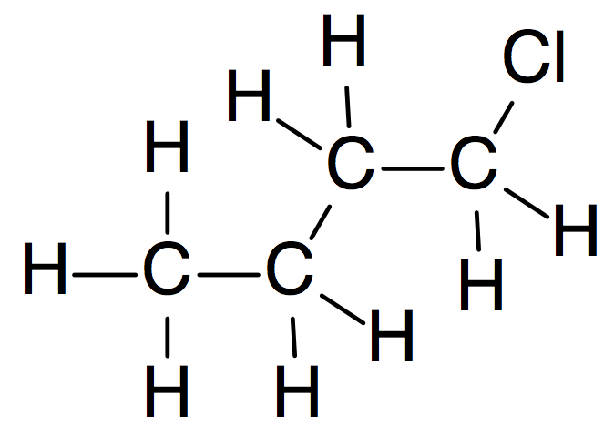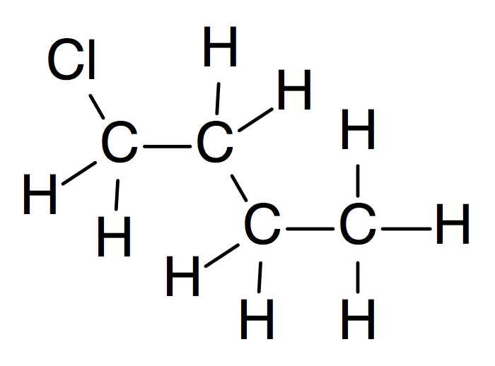

H₂O / H₃PO₄(s) / heat

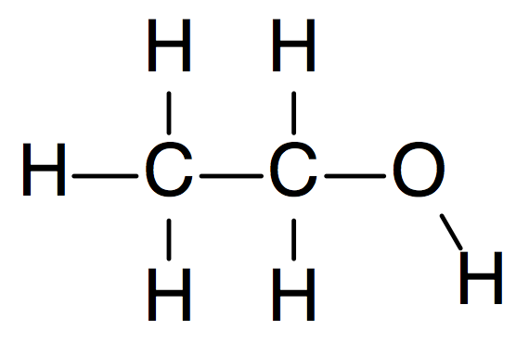

NaOH(aq)

Compound C
Semi-structural formula:

Conditions I:

Compound B
Name:

Conditions III:

Butyl ethanoate

- Draw the structural formula of Compound A in the box provided 1 mark
- Write the systematic name of Compound B in the box provided. 1 mark
- Write the semi-structural formula of Compound C in the box provided. 1 mark
- Write the Conditions required for reactions I, II and III 3 marks

(6 marks)

Question 3 (8 marks)
Bioethanol is a readily available, clean fuel for combustion engines.

- Why is bioethanol considered to be a renewable energy source?
(1 mark)

- Write the fully balanced equation for the fermentation process that converts glucose (C₆H₁₂O₆) to ethanol.
(2 marks)

- Ethanol can be reacted with fatty acids to make biodiesel in an esterification reaction. The mass spectrum below corresponds to a biodiesel produced by this type of esterification reaction.

- What is the molar mass of the ester?
(1 mark)

- Which fatty acid was reacted with ethanol to produce this compound? Refer to the Data Book and show your workings.
(2 marks)

- Write a fully balanced chemical equation for the esterification reaction between ethanol and the fatty acid identified in question above (Q3c. ii).
(1 mark)

- Write the chemical formula for the ion responsible for the peak at m/z = 255.
(1 mark)

End of Section B

